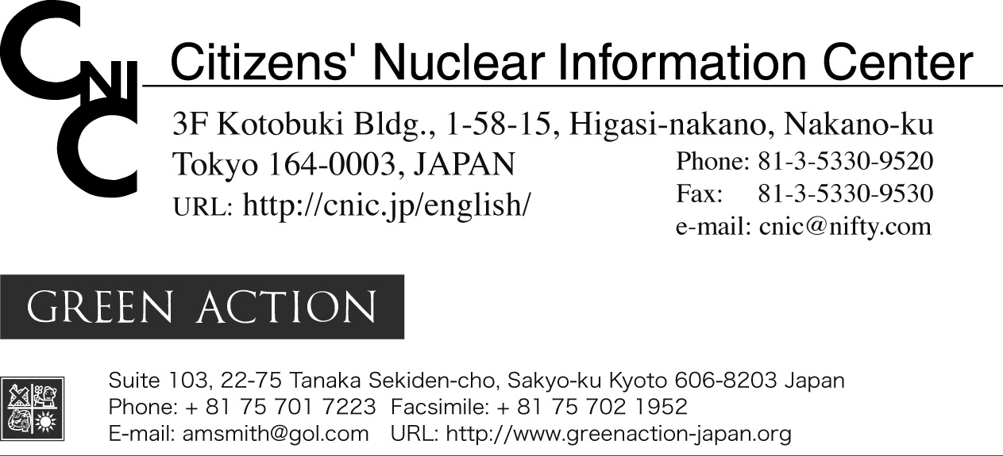

10 July 2006

Japan Should Withdraw its Opportunistic, Cynical and Impractical Offer
to Cooperate with the US Global Nuclear Energy Partnership

Statement by Citizens’ Nuclear Information Center and Green Action

Japan has opportunistically jumped on President George Bush’s Global Nuclear Energy Partnership (GNEP) bandwagon. Just when doubts were being expressed about the proliferation dangers of separating plutonium at the Rokkasho reprocessing plant in Aomori Prefecture, GNEP was like a gift from Uncle George.

The government is treating GNEP as a great opportunity to gain recognition of Japan’s unique position as the only Non Nuclear Weapons State (NNWS) member of the Non Proliferation Treaty with access to the full nuclear fuel cycle. Japan is the only NNWS with industrial scale facilities for both uranium enrichment and reprocessing of spent nuclear fuel.

The government also hopes that GNEP will provide a lifeline for Japan’s ailing nuclear industry. The nuclear research establishment can scarcely conceal its delight and nuclear manufacturers, faced with shrinking sales each year, will be only too happy to pick up any contracts that come their way. However, it is far less clear that electric power companies share this enthusiasm. They are the ones who will have to sell any electricity produced by the reactors envisaged under GNEP and they are under no illusions about the likely price.

Somewhere in all of this, the Japanese government has lost site of the fact that it is highly unlikely that GNEP could help provide the Japanese public with any substantive source of energy in any reasonable length of time.

Even if the government is not inclined to look the GNEP gift horse in the mouth, we believe that before Japan makes any firm promises and commits any money, a more balanced assessment is required. The following brief analysis highlights some major problems that the government has not addressed.

Key components of GNEP
Though the details are far from clear, GNEP promises to develop the following:
- proliferation-resistant spent nuclear fuel reprocessing technologies;
- “advanced burner reactors” that can use plutonium mixed with other radioactive wastes as fuel;
- small-scale reactors suitable for developing countries; and
- nuclear fuel supply arrangements whereby a limited number of “fuel supplier nations” provide fuel services to “user nations” which forego the right to fuel cycle technology.
Spent fuel would be returned to the supplier countries for reprocessing. This “cradle-to-grave” fuel leasing approach is supposed to reduce the risk of proliferation and reduce the radioactive waste going to geological repositories. Researchers and NGOs in the US have already debunked these promises, so here we restrict ourselves to stating a few of the reasons why GNEP will not achieve what it claims.

The proliferation-resistance of the proposed new reprocessing technologies is based on the idea that plutonium will not be separated in pure form. It is claimed that by including other radioactive elements (referred to variously as transuranics or actinides) in the final product their radioactivity will act as a barrier to people who might wish to divert the plutonium to nuclear weapons. However, as explained by Kang and von Hippel, the radioactivity of the product will be well below the level the International Atomic Energy Agency considers to be “self-protecting”. Hence, these new reprocessing technologies cannot be said to be proliferation-resistant. GNEP offers no solution to the proliferation problems of reprocessing. Rather, by highlighting the dangers of the separation process currently used, the so-called “PUREX” process, GNEP confirms that the Rokkasho reprocessing plant is dangerous from the perspective of nuclear proliferation.

The proposed advanced burner reactors and small-scale reactors don’t exist yet and there are huge technological, safety and economic obstacles to be overcome. They will not be commercially viable for decades, if ever, and in the meantime the plutonium stockpile and the radioactive waste mountain continue to grow.

As for the idea of establishing a group of authorized fuel supplier nations (the US Department of Energy referred to them as a “consortium”, but a more honest label would be a “cartel”), it is hard to believe that the rest of the world will willingly subject itself to eternal dependence on a handful of privileged countries.

Japan’s offer of cooperation
Clearly GNEP is far from being a practical proposal promising a solution to the current pressing problems associated with nuclear energy and the nuclear fuel cycle. Nevertheless, the Japanese government is falling over backwards to appear supportive. A May 5th Ministry of Education, Culture, Sports, Science and Technology document outlined five areas of research and development cooperation:
- joint collaboration on the design of a US nuclear recycling facility.
- joint development of FR/FBR fuel utilizing Joyo and Monju.
- joint development of structural material for streamlined, compact reactors.
- joint development of major components (such as steam generator) for sodium-cooled reactors.
- joint development of safeguards concepts for nuclear fuel recycling facility based on Japan's experience.
(Note: The English translation includes “FR/FBR” in item 2, although no corresponding words appear in the Japanese version.)

Japan is already doing research in all of these areas. Rather than offering anything new, the government is hoping to gain recognition for its existing programs and to be part of the action in the massive long-term spending program that GNEP will entail. However, besides being very expensive and totally impractical, GNEP has other features which will inevitably prove to be indigestible for Japan.

The issue that will attract the broadest opposition is the “cradle-to-grave” approach to fuel supply. GNEP envisages fuel supplier nations taking back the spent fuel, reprocessing it and burning the plutonium and minor actinides in advanced burner reactors. Japan does not now have the capacity to reprocess all the spent fuel from its own nuclear reactors and it is stretching the imagination to think that it will ever have the capacity to reprocess spent fuel from overseas. However, even if the capacity problem could be solved, prefectural and local governments are unlikely to agree to accept spent nuclear fuel from overseas. GNEP is vague about what will happen to the waste from reprocessing foreign spent fuel, but it implies that the fuel supplier nations will also end up providing the final waste repositories. Given the difficulty of finding a repository for Japan’s own high-level waste, it is inconceivable that there will be any volunteers to accept foreign waste.

Anticipating this problem, the Japanese government has already indicated that it will not take back spent fuel from overseas. This undermines Japan’s aspirations to the status of “fuel supplier nation”. We believe GNEP’s chances of success are zero in any case, but when aspiring fuel supplier nations pick and choose in this way, GNEP is exposed for the fraud that it is.

Japan is promoting its fast breeder reactor program as an area of potential GNEP cooperation. There is an inherent contradiction in this. GNEP does not propose the use of fast breeder reactors. It talks about fast burner reactors. Breeder reactors are designed to “breed” plutonium in a blanket of uranium around the core. The plutonium produced in this way is “super weapons grade”, because of the very high percentage of the isotope of plutonium-239. Breeder reactors are therefore completely incompatible with non-proliferation. Other than the breeding component, the basic technology for fast breeders and fast burners is the same, but if GNEP is really set up to address proliferation concerns, the Japanese government will have to abandon its dream of nuclear power based on breeder reactors.

The government’s offer of cooperation involving the sodium-cooled fast reactors Joyo and Monju, both of which were designed to be breeder reactors, is a good illustration of the cynical way it is approaching GNEP. No doubt it hopes the US will relent and expand the scope of GNEP to include breeders. It would have been encouraged by President Bush’s remarks at a press conference during Prime Minister Koizumi’s recent visit to the US:

“We discussed…our contributions to some research and development that will help speed up fast breeder reactors and new types of reprocessing so that we can help deal with the cost of globalization when it comes to energy…” (White House, 29 June 2006)
The President might not understand the difference between “fast burner reactors”, as originally proposed for GNEP, and “fast breeder reactors”. However, if he does, then his comment is an early indication that Japan’s involvement in GNEP, far from strengthening the non-proliferation system, is more likely to further undermine any spurious non-proliferation claims that might be made for GNEP.

There are also other ways in which Japan’s involvement in GNEP will undermine the non-proliferation system. The Non Proliferation Treaty (NPT) enshrines discrimination between Nuclear Weapons States (NWS) and Non Nuclear Weapons States (NNWS). Japan adds a further level of discrimination between nuclear fuel cycle states (NFCS) and non nuclear fuel cycle states (NNFCS). Japan’s involvement in GNEP will reinforce this discrimination. However, as Mohamed ElBaradei has repeatedly pointed out, the discrimination between NWS and NNWS is unsustainable. Likewise, discrimination between NFCS and NNFCS will be unsustainable. Japan’s defacto status as a NFCS is already generating envy overseas and experts have warned that operation of the Rokkasho reprocessing plant could undermine international efforts to discourage other countries from building their own reprocessing and enrichment facilities. The whole framework of GNEP ignores these basic obstacles.

Costs
Japan’s nuclear fuel cycle program has been under development in the name of "energy independence" for half a century. Where has it gotten Japan? Despite spending several trillion yen (tens of billions of dollars) of ratepayer and taxpayer money, closing the Japanese fuel cycle has been an economic failure and a detriment to public safety.

Japan's Rokkasho reprocessing plant, located in Aomori Prefecture in the north of Japan, is now undergoing "active testing" leading up to commercial operation scheduled for August 2007. The plant is slated to separate plutonium from spent nuclear fuel for use in Japan's nuclear reactors. At a cost of 2.3 trillion yen (about 20 billion U.S. dollars) to ratepayers, it is said to be the most expensive plant ever built in the history of the world. The Japanese government and utilities estimate that the total bill for choosing the reprocessing option and operating the Rokkasho reprocessing plant will be 19 trillion yen (about $160 billion U.S.), far more than disposing without reprocessing. Critics say it will cost far more. A second reprocessing plant will be needed for the spent fuel that Rokkasho cannot handle. This is estimated to raise costs to 43 trillion yen (about $375 billion U.S.).

Other parts of the nuclear fuel cycle program fare no better. Scheduled to have started in 1999, the use of mixed plutonium-uranium oxide (MOX) fuel in commercial nuclear reactors is yet to begin. With the exception of minor testing undertaken years ago, the program has to date produced no electricity. The third pillar of Japan's nuclear fuel cycle program is its fast breeder reactor program, which after 50 years of development has produced a grand total of 1 hour of electricity. Future prospects appear no brighter. The government's current nuclear energy policy has the fast breeder commercialized by 2050, an astonishing 70 years behind the original schedule set in 1961.

With a record like this, one would have thought that, rather than jumping on the GNEP bandwagon, the Japanese government would be looking for a way out of its nuclear fuel cycle program. Pursuing the elusive dream of “closed” nuclear fuel cycles, such as those promised by GNEP, will mire Japan and the US in a quagmire of higher nuclear power costs, increased plutonium surplus, and snowballing nuclear waste headaches.

Conclusion
GNEP will not reduce the risk of nuclear proliferation. It will not reduce the burden of radioactive waste produced by nuclear power plants. Nor will it contribute to meeting the world’s energy demand. The money wasted on GNEP would be far better spent on sustainable alternatives to fossil fuels and nuclear power.

The PUREX process of separating plutonium from spent nuclear fuel, used at the Rokkasho reprocessing plant, gives rise to serious proliferation risks. Likewise, there are serious proliferation risks associated with fast breeder reactors, including the Monju prototype fast breeder reactor. These risks are in addition to the safety and radioactive waste risks associated with the Rokkasho reprocessing plant and Monju.

The Japanese government is not in a position to make a substantial contribution to GNEP’s purported aims. Rather, the government’s offer to cooperate with GNEP is opportunistic, cynical, and impractical. Like its contribution to the “coalition of the willing” in Iraq, its contribution to GNEP will be purely symbolic.

Demands
- The Japanese government should withdraw its opportunistic, cynical, and impractical offer to cooperate with GNEP and engage in a public debate about the proliferation, safety and radioactive waste problems arising from its nuclear fuel cycle policies. Unlike the deliberations of the Atomic Energy Commission’s Nuclear Policy-Planning Council, which led to the production of the Framework for Nuclear Energy Policy, a process should be established in which serious problems are debated honestly and scientifically. Conclusions should not be reached on the basis of pre-rigged numbers on committees, but on the basis of the merits of the arguments.
- Active testing of the Rokkasho reprocessing plant should be stopped.
- Japan’s fast breeder program, including moves to restart the Monju prototype fast breeder reactor, should be stopped.

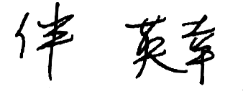

Hideyuki BAN
Co-Director,
Citizens’ Nuclear Information Center

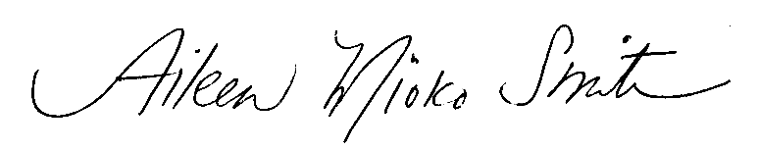

Aileen Mioko Smith
Director,
Green Action

Contacts:
Aileen Mioko Smith (Director, Green Action) 81-75-701-7223
Hideyuki Ban (Co-Director, CNIC) 81-3-5330-9520
Philip White (International Liaison Officer, CNIC) 81-3-5330-95220

1. The following is a selection of references debunking the claims of GNEP (including articles published before GNEP was announced). “Nuclear Terrorism and Nuclear Reactors, Extracting Plutonium from Nuclear Reactor Spent Fuel Would Increase Risk of Terrorists Acquiring Nuclear Weapons and Exacerbate Nuclear Waste Problem”, Union of Concerned Scientists http://www.ucsusa.org/global_security/nuclear_terrorism/extracting-plutonium-from-nuclear-reactor-spent-fuel.html “The limited proliferation-resistance benefits of the nuclear fuel cycles being researched by the Department of Energy’s Advanced Fuel Cycle Initiative”, June 08, 2005, by Jungmin Kang and Frank von Hippel, Program on Science and Global Security, Princeton University http://www.armscontrolcenter.org/archives/001711.php “Is U.S. Reprocessing Worth The Risk?” Arms Control Today, Steve Fetter and Frank N. von Hippel, September 2005 http://www.armscontrol.org/act/2005_09/Fetter-VonHippel.asp “Fast Reactors: Unsafe, Uneconomical, and Unable to Resolve the Problems of Nuclear Power”, Public Citizen http://www.citizen.org/documents/FastReactors.pdf The Nuclear Alchemy Gamble: An Assessment of Transmutation as a Nuclear Waste Management Strategy, Institute for Energy and Environmental Research, August 25, 2000 http://www.ieer.org/reports/transm/report.pdf summary available at http://www.ieer.org/sdafiles/vol_8/8-3/transm.html
Ibid., Kang and von Hippel
“MEXT’s Proposal of Cooperation areas in GNEP”, Ministry of Education, Culture, Sports, Science and Technology, May 5, 2006
http://cnic.jp/english/topics/cycle/backend.html "In November [2003] the Federation of Electric Power Companies of Japan stated that total back-end costs amount to about 19 trillion yen (18.8 trillion). This includes the construction, operation, repair, dismantling and waste management of Rokkasho Reprocessing Plant, plus the MOX plant and the transport, storage and disposal of radioactive waste returned from overseas...The total cost calculations for the plant are based on it operating for 40 years from 2006 then taking 32 years to dismantle. In total, the Rokkasho Reprocessing Plant alone consumes 11 trillion yen, or 60% of the total back-end costs."）

