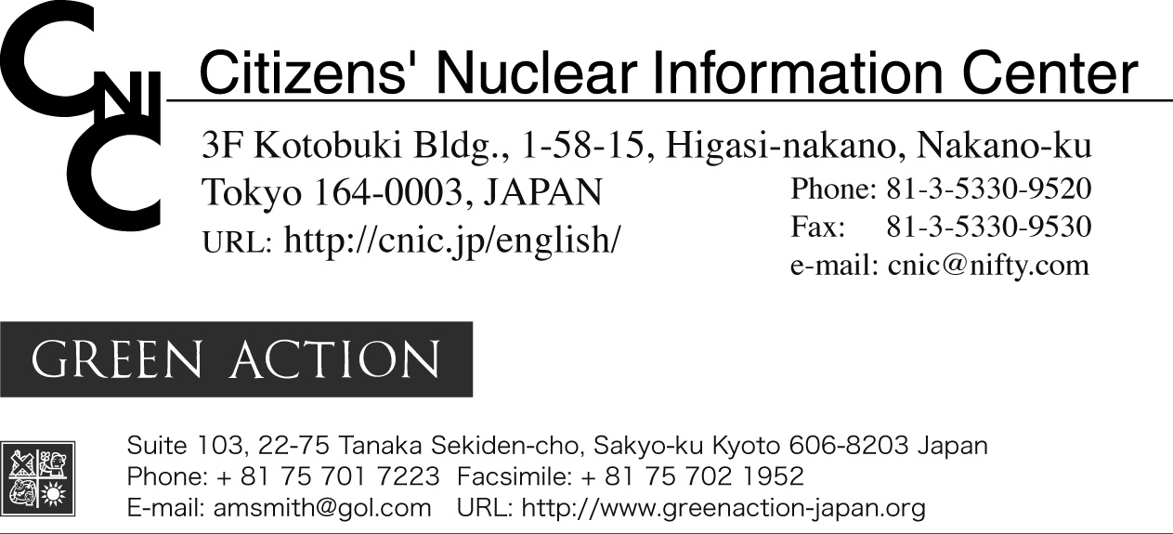

Japan Should Withdraw its Opportunistic, Cynical and Impractical Offer
to Cooperate with the US Global Nuclear Energy Partnership

Lessons the G8 Can Learn from Japan: the Nuclear Fuel Cycle is
an Economic Failure Providing No Energy

For Immediate Release: 14 July 2006
Contact: Philip White (CNIC) 03-5330-9520

Tokyo and Kyoto, Japan----Japan has opportunistically jumped on President George Bush's Global Nuclear Energy Partnership (GNEP) bandwagon in the hope of aiding its troubled nuclear fuel cycle program and gaining recognition for Japan's unique position as the only Non Nuclear Weapons State (NNWS) member of the Non Proliferation Treaty with access to the full nuclear fuel cycle.

It is difficult to imagine, however, that Japan could play a significant role in GNEP seeing that its own nuclear waste problems at home are in a prolonged state of crisis, and its fast breeder reactor and MOX (mixed plutonium uranium oxide) fuel use programs are plagued with delays.

Nevertheless, Kenji Kosaka, Japan’s Minister of Education, Culture, Sports, Science and Technology (MEXT), presented presented a document to US Department of Energy Secretary Bodmon on May 5th outlining five areas of research and development cooperation including collaboration on the design of a US nuclear recycling facility and joint development utilizing Joyo and Monju reactors.

However, on July 6th, when CNIC asked MEXT representatives about the May 5th statement it was told, "nothing concrete has been decided". It was also told that there is no budget set aside for this proposal.

"When the G8 discusses the nuclear fuel cycle, it should bear in mind the lessons from Japan's experience. Japan's nuclear fuel cycle program has been under development in the name of 'energy independence' for half a century. However, not a single watt of electricity is being generated by it today. Despite spending several trillion yen (tens of billions of U.S. dollars) of ratepayer and taxpayer money, closing the Japanese fuel cycle has been an economic failure and a detriment to public safety,” stated Aileen Mioko Smith, director of Green Action.

Japan's Rokkasho reprocessing plant, located in Aomori Prefecture in the north of Japan, is now undergoing "active testing" leading up to commercial operation scheduled for August 2007. The plant is slated to separate plutonium from spent nuclear fuel for use in Japan's nuclear reactors. At a cost of 2.3 trillion yen (about 20 billion U.S.) to ratepayers, it is said to be the most expensive plant ever built in the history of the world.

The Japanese government and utilities estimate that the total bill for choosing the reprocessing option and operating the Rokkasho reprocessing plant will be 19 trillion yen (about $160 billion U.S.), far more than disposing without reprocessing. The calculations are highly optimistic since it assumes the reprocessing plant will operate at full capacity. A second reprocessing plant will be needed for the spent fuel that Rokkasho cannot handle.

Other parts of the nuclear fuel cycle program fare no better. Scheduled to have started in 1999, the use of mixed plutonium-uranium oxide (MOX) fuel in commercial nuclear reactors is yet to begin.

The third pillar of Japan's nuclear fuel cycle program is its fast breeder reactor program, which after 50 years of development has produced a grand total of 1 hour of electricity. Future prospects appear no brighter. The government's current nuclear energy policy has the fast breeder commercialized by 2050, an astonishing 70 years behind the original schedule set in 1961.

Since Japan does not now have the capacity to reprocess all the spent fuel from its own nuclear reactors, it is stretching the imagination to think that it will ever have the capacity, under the GNEP plan, to reprocess spent fuel from overseas. And given the difficulty of finding a repository for Japan's own high-level waste, it is inconceivable that there will be any volunteers to accept foreign waste.

Anticipating this problem, the Japanese government has already indicated that it will not take back spent fuel from overseas. This undermines Japan's aspirations to the status of "fuel supplier nation". We believe GNEP's chances of success are zero in any case, but when aspiring fuel supplier nations pick and choose in this way, GNEP is exposed for the fraud that it is.

With a record like this, one would have thought that, rather than jumping on the GNEP bandwagon, the Japanese government would be looking for a way out of its nuclear fuel cycle program. Pursuing the elusive dream of "closed" nuclear fuel cycles, such as those promised by GNEP, will mire Japan and the US in a quagmire of higher nuclear power costs, increased plutonium surplus, and snowballing nuclear waste headaches.

The government hopes that GNEP will provide a lifeline for Japan's ailing nuclear industry. However, it is far less clear that electric power companies share this enthusiasm. They are the ones who will have to sell any electricity produced by the reactors envisaged under GNEP and they are under no illusions about the likely price.

It is important to note that somewhere in all of this, the Japanese government has lost site of the fact that it is highly unlikely that GNEP could help provide the Japanese public with any substantive source of energy in any reasonable length of time.

Not only will GNEP not contribute to meeting the world's energy demand, GNEP will not reduce the risk of nuclear proliferation. It will not reduce the burden of radioactive waste produced by nuclear power plants. The money wasted on GNEP would be far better spent on sustainable alternatives to fossil fuels and nuclear power.

The Japanese government is not in a position to make a substantial contribution to GNEP's purported aims. Rather, the government's offer to cooperate with GNEP is opportunistic, cynical, and impractical. Like its contribution to the "coalition of the willing" in Iraq, its contribution to GNEP will be purely symbolic.

Japan should not participate in GNEP. Rather, it should address the problems nuclear power and the nuclear fuel cycle have created at home, and invest in non-nuclear alternatives---energy conservation, efficiency, and sustainable, renewable energy.
------------
For a more detailed commentary see: http://cnic.jp/english/news/newsflash/2006/gnep11Jul06.html

