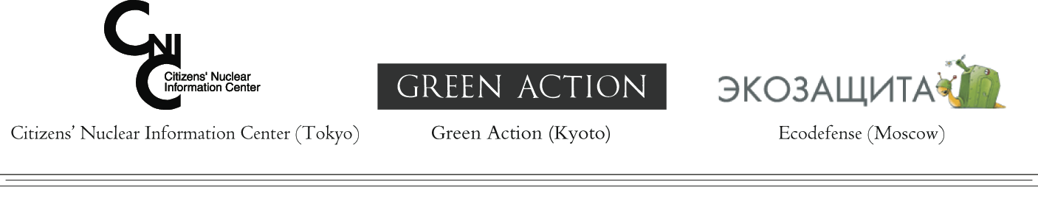

For international release: February 28, 2007

STATEMENT BY JAPANESE AND RUSSIAN ENVIRONMENTAL GROUPS

CONSEQUENCES OF JAPAN-RUSSIA
URANIUM ENRICHMENT DEAL

Today the prime ministers of Japan and Russia are meeting in Tokyo. According to media reports, part of the negotiations will focus on a new nuclear agreement allowing Japanese nuclear material to be sent to Russia. It is planned that uranium extracted from spent nuclear fuel reprocessed in the UK and France will be enriched in Russia for use as nuclear fuel for Japanese nuclear power plants. Earlier this month, the Yomiuri Shimbun (1) and various Russian media (2)(3) reported that “Japan has entered into final negotiations that would see Russia enriching Japan's uranium”.

It is clear that the Russian uranium enrichment plant in Angarsk will serve as the main enrichment plant for such a deal, because the Rosatom, Russian nuclear agency, has announced that it is establishing a so-called “international center” for uranium enrichment at Angarsk. The aim of the center is to provide a guaranteed supply of uranium fuel for countries which do not enrich uranium themselves, including for countries under international sanctions such as Iran, India and others. Although Japan has an enrichment plant, the plant’s capacity is only a fraction of Japan’s total demand.

If a deal is signed between Japan and Russia, uranium extracted from Japanese spent fuel will be transported nearly 10,000 km to the Angarsk uranium enrichment plant near lake Baikal, a UNESCO World Heritage site. Transportation over such a long distance may become a target for terrorist attack, or cause transport accidents leading to large releases of radioactivity.

Uranium enrichment and the production of nuclear fuel result in enormous amounts of radioactive waste, which has to be stored and isolated from the environment permanently. According to Russian environmental groups, there is over 100,000 tons of radioactive waste already stored in Angarsk. The Russian nuclear industry has no plan for disposal of that waste. The waste is stored under the open sky in partly corroded containers and poses a threat of radioactive leakages. Such leakages may reach lake Baikal, contaminating the largest reservoir of non-salt water on Earth.

There are also concerns that Japan’s proposal to send uranium to Russia for enrichment could further undermine the international non-proliferation regime. Japan cannot be confident that Japanese nuclear material will not be diverted to Iran, or to other countries suspected of developing nuclear weapons. Russia traditionally uses its own resources (including down-blending of highly enriched uranium to the enrichment level of uranium fuel for light-water reactors) to meet its own demand. Uranium sourced from other countries is more likely to be exported. The inadequacy of IAEA safeguards in nuclear weapons states and Russia’s avowed determination to supply fuel for Iran’s Bushehr nuclear power plant are grounds for serious concern.

Local residents are totally opposed to the plan of establishing an international center for uranium enrichment and new enrichment contracts. Since December 2006, protests have been happening on a weekly basis. People are demanding that authorities withdraw from new enrichment contracts in order to stop the growth of radioactive waste stockpiles near the highly sensitive Baikal ecosystem. Both Japan and Russia must uphold democratic values and respect the wishes of the local residents. We call on both governments to withdraw from negotiations over enriching Japanese uranium in Russia.
Contact information:
Green Action: + 81-75-701-7223 or +81-90-3620-9251 (Aileen Mioko Smith)
email: amsmith@gol.com web: http://www.greenaction-japan.org/
Citizens’ Nuclear Information Center: +81-3-5330-9520 (Philip White)
email: cnic@nifty.com web: http://cnic.jp/english/
Ecodefense (Moscow, Russia): +7-985-7766281 or 903-2997584 (Vladimir Slivyak)
email: ecodefense@online.ru web: http://www.ecodefense.ru
References:
(1) Yomiuri Shimbun "Nuclear fuel agreement mixed blessing", 22 February 2007
http://www.yomiuri.co.jp/dy/business/20070222TDY03004.htm
(2) RIA Novosti "Atomic power will be the theme of visit of Fradkov to Tokyo" 27 February 2007
http://www.rian.ru/politics/foreign/20070227/61275555.html
(3) Newspaper "Vedomosti (together with Financial Times and Wall Street Journal)", article "Atomic power will be the theme of visit of Fradkov to Tokyo", 27 February 2007
http://www.vedomosti.ru/newsline/index.shtml?2007/02/27/390346

